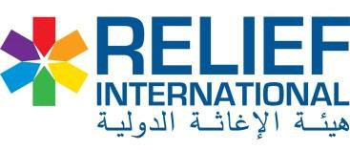

Annex – A (ECHO - Waste management supplies)

# | Item Description | Unit | QTY | Unit Cost SDG | Total cost SDG
1 | Heavy Gloves | no | 35
2 | Mask (50 peace per carton) new date | box | 100
3 | Lab Coat green color with AIC & RI logo | Packs | 25
4 | Safety Boots (size 42-45) | no | 25
5 | Apron with AIC & RI logo | Pcs | 35
6 | Coverall (T-shirt and trioses separately) | Pcs | 25
7 | Goggles | Pcs | 25
Total cost : |  | SDG

Annex – B (ECHO - WASH supply items for HFs and IDP location including cleaning tools

# | Item Description | Unit | QTY | Unit Cost SDG | Total cost SDG
1 | Solid sops 180g (40 pes per carton) | Carton | 60
2 | Liquid soaps (500 ml) | Pcs | 140
3 | Dettol’s 500 ml | Pcs | 140
4 | Brooms (plastic) | Pcs | 50
5 | Towel (Biskeer) | Pcs | 100
6 | Bucket 12 litters with ECHO and RI logo | Pcs | 28
7 | Waste collector plastic | Pcs | 28
8 | Waste collector (Sac) | Pcs | 500
9 | Local broom | PCs | 35
11 | Bins middle size with ECHO and RI logo | PCs | 35
12 | Bins big size with ECHO and RI logo | PCs | 35
13 | Water container ( Haza) 16 litter with logo | Pcs | 7
14 | Water cup Iron 500 ml with logo | Pcs | 35
Total cost : |  | SDG

